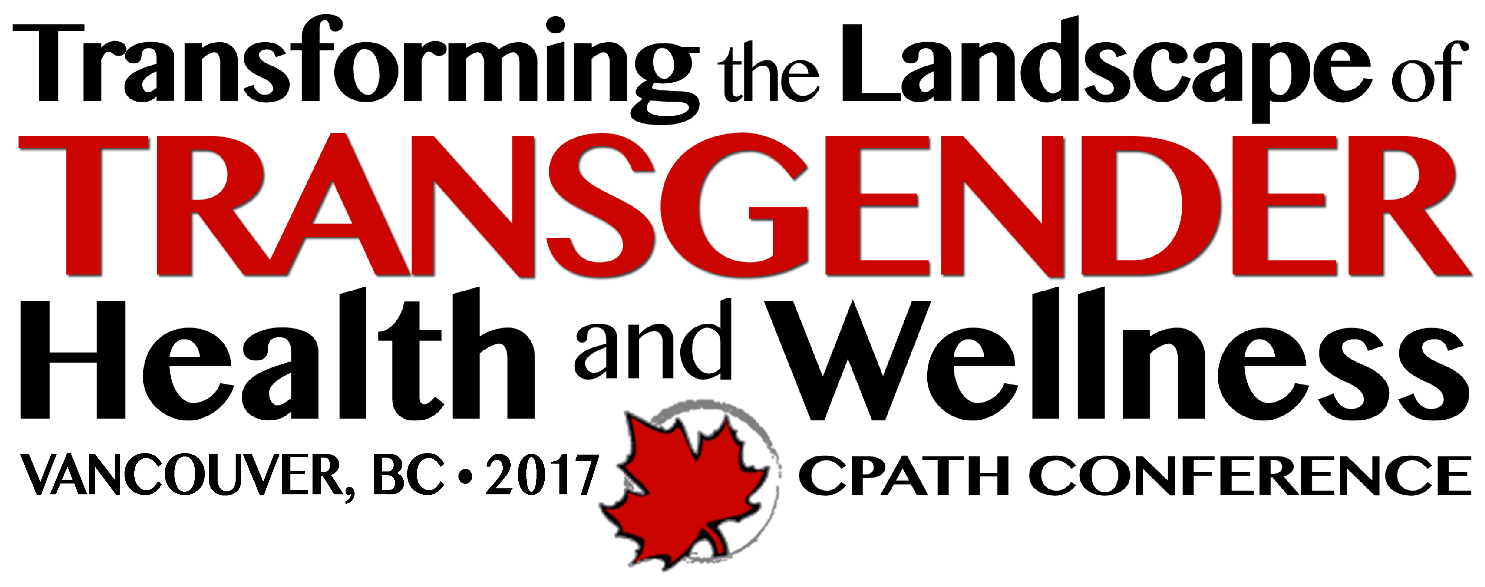

Canadian Professional Association for Transgender Health

2017 Conference Exhibiting and Advertising Opportunities

The first – and largest – national professional association for transgender health in the world, the Canadian Professional Association for Transgender Health (CPATH) is known nationally and internationally to have a finger on the pulse of trans health, wellness and care. CPATH is an interdisciplinary professional organization which works to support and advocate for the health, wellbeing, and dignity of trans and gender diverse people by educating professionals and enabling knowledge exchange to develop and promote best practices; facilitating networks and fostering supportive environments for professionals working with and for trans people; and encouraging research to expand knowledge and deepen understanding about sex and gender diversity.

Health and wellness is a dynamic process of change and growth that involves the intersections of many factors. These include a knowledgeable and empowered community and access to health care that encompasses best practices and evidence based research across the lifespan. Transforming the Landscape of Transgender Health and Wellness will showcase excellence in research, clinical practice, program development, policy and systems change.

The 2017 CPATH Pre-Conference Training and Conference is taking place Wednesday, October 25 to Sunday, October 29 at the Coast Plaza Hotel & Suites, 1763 Comox St., Vancouver, British Columbia.

Designed to Appeal to a Wide Audience

CPATH’s conferences have consistently featured the latest evidence and approaches to innovative research findings, clinical practices, models of care, and community-based approaches to improving transgender health and wellness. Unique in Canada, the conference provides an opportunity for participants to meet face to face on topics specifically related to trans health.

CPATH’s conferences attract a multidisciplinary group of health care providers, clinicians, health administrators and policy-makers, educators, lawyers, researchers, government and non-governmental organizations, change agents from within trans communities and students and others, with a shared interest in the health and wellbeing of trans and gender variant children, youth, adults, and older adults.

Building on CPATH’s previous successes, the 2017 Vancouver conference is poised to provide opportunities for learning and knowledge exchange, to enhance clinical practice and capacity and explore new and emerging research. The conference will also contribute to building and strengthening networks and supports for transgender and gender non-conforming people and those who are key to providing health and wellness programs and services for trans communities.

The 2015 Halifax Conference had over 220 participants. CPATH anticipates that the Vancouver 2017 Conference will attract over 300 participants.

New in 2017 – Pre-Conference Training Wednesday, October 25 & Thursday, October 26

An expanded 2 day pre-conference training program is being offered for a variety of experience levels but will be particularly geared to new and experienced practitioners.

Expert trainers will offer sessions that will improve participant’s knowledge, and
develop skills to enhance their understanding of and work with trans and gender creative individuals, and increase their capacity to provide gender affirming and primary health care services to transgender patients.

Pre-conference training will be designed for a variety of experience levels but will be
particularly geared to experienced practitioners.

All pre-conference training sessions will be CME/CEU accredited for Mainpro-M1 credits.
Exceptional Opportunities

As a Conference Partner of Transforming the Landscape of Transgender Health and Wellness, you have an opportunity to align your organization’s objectives with issues of critical importance to the health and well-being of transgender people, and to the sectors that support them. Each conference partner will be well positioned to demonstrate their leadership and commitment to the field.

Program Advertising Opportunities

A limited number of ads will be included in the online Pre-Conference Program and in the magazine format on-site Final Conference Program (posted to CPATH’s website, and distributed througout Canada).

Online Pre-Conference and onsite Final Magazine-Format Conference Program

Size (width x height, in inches) Dimensions Cost

Full Page 7 x 9 $1,250

Half Page 7 x 4.5 $ 500

Quarter Page 3.5 x 4.5 $ 275

Advertisement Specifications

Resolution should be 300 dpi.
Please submit your ad using any of the following formats:
• PDF
• JPEG
• TIFF
• EPS

Exhibit at the CPATH 2017 Conference, showcase new products and services and build new relationships.
Private Sector (for profit) – $600
- 10 x 10 space includes draped table and two chairs
- Your company’s website URL posted on conference website
Government, Large Not-for-Profits, Small Businesses – $350
- 10 x 10 space includes draped table and two chairs
- Your company’s website URL posted on conference website
Small Not-for-Profit Agencies – $250
- 10 x 10 space includes draped table and two chairs
- Your company’s website URL posted on conference website

Includes:
- Draped and skirted 6’ table and two chairs
- Your company’s website URL posted on conference website
- Name recognition in on-line pre-conference program and onsite magazine format final conference program

Please download and complete the Exhibit and Advertiser Application & Registration form and email to rachelandassoc@xplornet.com or mail with payment to address below.

Rachel Gillooly & Associates
CPATH 2017 Conference Organizers
1013 Pinoak Lane, Minden, ON K0M 2L1

Questions? Email rachelandassoc@xplornet.com or call 705-454-8107

